Airline Company

- Part 1: Database design and optimisation

ER DIGRAM

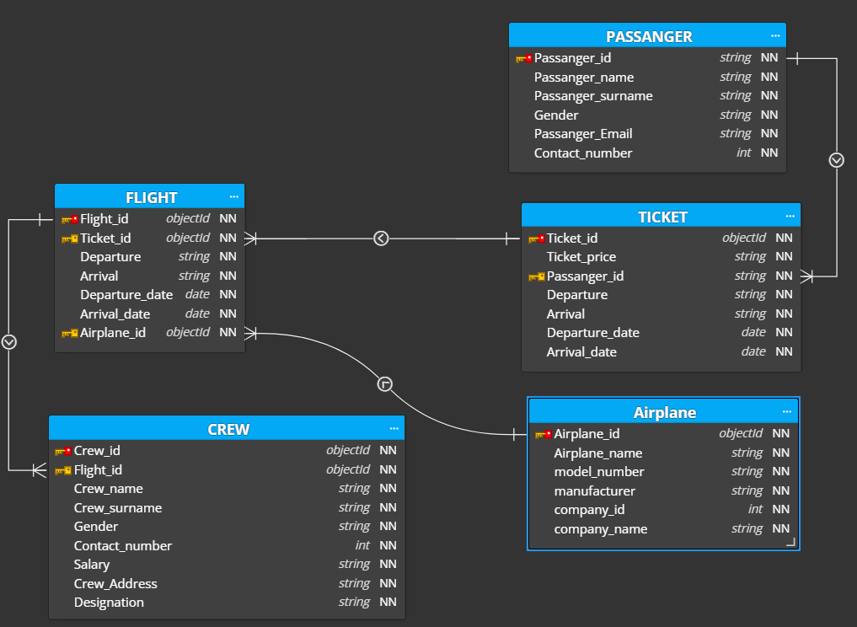

Passanger_Table

Passanger_id | Passanger_name | Passanger_surname | Gender | Email_address | Contact_number
79210 | Abdul Rehman | Wachocho | M | Wachocho@gmail.com | 312234212
79211 | Abdul Sami | Wadho | M | samiwadho@gmail.com | 312424121
79212 | kashif Hussain | Wachocho | M | kashif@gmail.com | 333234212
79213 | Sabir Ali | Hakro | M | Sabir@gmail.com | 345554323
77443 | Safder Shah | Shah | M | Shah@gmail.com | 312325777
24444 | Zanib gul | khan | M | Zanib@gmail.com | 317777888
25333 | Abdulluah | Wadho | M | Abdulluah@gmail.com | 305556696
33211 | Abdul Ghaffer | kori | M | Ghaffer@gmail.com | 333999944
42112 | Abdul Ahad | Lashari | M | Ahad@gmail.com | 315665656
98989 | Nida sami | Rajpot | F | Nida@gmail.com | 3166666655
77666 | Kubra khan | Khan | F | Kubra@gmail.com | 345666664
66644 | Abdul Samed | Sommro | M | Sommro@gmail.com | 36455565

Airplane table

Airplane_id | Airplane_name | Model_number | Manufacturer | Company_id
980110 | Iqbal fly | 302 | German | 33412802
931110 | Big Fly | 367 | Englind | 5423337
912356 | Round Chick | 321 | China | 33421223
942154 | Arid Arrow | 425 | American | 34444402
932221 | Night fly | 643 | American | 34444402
924492 | Jinnah fly | 123 | China | 33421223
976544 | Capable Craft | 970 | German | 33412802
984322 | Red King | 234 | China | 33421223
943232 | Round Chick | 302 | German | 33412802

Ticket table

Ticket_id | Ticket_price | Passanger_id | Departure | Arrival | Departure_date | Arrival_date
12 | 50000 | 79210 | Karachi | Dubai | 03/01/20 | 03/01/20
13 | 50000 | 79211 | Karachi | Dubai | 03/01/20 | 03/01/20
14 | 50000 | 79212 | Karachi | Dubai | 03/01/20 | 03/01/20
15 | 50000 | 79213 | Karachi | Dubai | 03/01/20 | 03/01/20
321 | 50000 | 77443 | Dubai | Qatar | 04/01/20 | 04/01/20
1321 | 200000 | 24444 | Dubai | Texis | 05/01/20 | 06/01/20
123 | 100000 | 25333 | Dubai | France | 05/01/20 | 06/01/20
3242 | 35000 | 33211 | Lahore | Mumbay | 07/01/20 | 07/01/20
4321 | 30000 | 42112 | Karachi | Dhaka | 06/01/20 | 06/01/20
3421 | 90000 | 98989 | Dubai | Moscow | 08/01/20 | 08/01/20
3222 | 30000 | 77666 | Islamabad | Dubai | 09/01/20 | 09/01/20
2323 | 39000 | 66644 | Lahore | New Delhi | 06/01/20 | 06/01/20

Flight table
Flight_id | Ticket_id | Departure | Arrival | Departure_date | Arrival_date
570999 | 12 | Karachi | Dubai | 03/01/20 | 03/01/20
570999 | 13 | Karachi | Dubai | 03/01/20 | 03/01/20
570999 | 14 | Karachi | Dubai | 03/01/20 | 03/01/20
570999 | 15 | Karachi | Dubai | 03/01/20 | 03/01/20
570323 | 321 | Dubai | Qatar | 04/01/20 | 04/01/20
570523 | 1321 | Dubai | Texis | 05/01/20 | 06/01/20
542339 | 123 | Dubai | France | 05/01/20 | 06/01/20
570999 | 3242 | Lahore | Mumbay | 07/01/20 | 07/01/20
574233 | 4321 | Karachi | Dhaka | 06/01/20 | 06/01/20
574329 | 3421 | Dubai | Moscow | 08/01/20 | 08/01/20
572323 | 3222 | Islamabad | Dubai | 09/01/20 | 09/01/20
53229 | 2323 | Lahore | New Delhi | 06/01/20 | 06/01/20

Crew table

Crew_id | Flight_id | Crew_name | Crew_surname | Gender | Contact_number | Salary | Crew_address | Desegination
900290 | 570999 | Abdul Ahad | Gujjar | M | 923433543341 | 150000 | Old power house north karachi | Pilot
900291 | 570999 | Abdul Sami | Mughal | M | 923123453312 | 88000 | Gulshan-e-Johar block 7 | Crew_staff
900292 | 570999 | Anna Mustafa | Rajpoot | M | 923433003323 | 95000 | Gulshan-e-Iqbal block 2 | Crew_staff
988777 | 542339 | Zesshan Hussain | Jutt | M | 923433543341 | 125000 | Gulshan-e-Johar block 9 | Pilot
988778 | 542339 | Sameera Ayan | Lashari | F | 923143344444 | 90000 | Gulshan-e- Iqbal block 6 | Crew_staff
988779 | 542339 | Fatima | Butt | F | 923466633777 | 80000 | Gulshan-e-Johar block 5 | Crew_staff
866662 | 574233 | Sabir Ali | Wadho | M | 923334555566 | 150000 | Gulshan-e- Iqbal block 18 | Pilot
866663 | 574233 | Ali Raza | Sheikh | M | 923312424323 | 90000 | Gulshan-e-Johar block 8 | Crew_staff
866664 | 574233 | Alina Sami | Butt | F | 923499966667 | 80000 | Gulshan-e- Iqbal block 18 | Crew_staff
477885 | 570999 | Ahmed hussain | Arain | M | 923434332335 | 60000 | Shah Faisal block 15 | Pilot
477886 | 570999 | Baber Ali | Jogi | M | 923056455555 | 60000 | Gulshan-e- Iqbal block 18 | Crew_staff
477887 | 570999 | Daniyal Ahmed | Khan | M | 923434332335 | 67000 | Gulshan-e- Iqbal block 18 | Crew_staff
677738 | 574233 | Faisal Ali | Shah | M | 923433003323 | 95000 | Shah Faisal block 1 | Pilot
677739 | 574233 | Ibrahim Shah | Wani | M | 923022224412 | 50000 | Kachi colany block 14 | Crew_staff
677740 | 574233 | Imran Ali | Talpur | M | 923333900011 | 80000 | Gulshan-e-Johar block 13 | Crew_staff
239995 | 574329 | Umar Taj | Zardari | M | 923433003323 | 95000 | Shah Faisal block 3 | Pilot
239996 | 574329 | Tanveer Ali | Hakro | M | 92319233422 | 89000 | Gulshan-e-Iqbal block 2 | Crew_staff
239997 | 574329 | Ibrahim Shah | Wani | M | 923022224412 | 50000 | Kachi colany block 14 | Crew_staff
899772 | 572323 | Fayaz Ahmed | Qureshi | M | 923023244455 | 150000 | Gulshan-e-Johar block 6 | Pilot
899773 | 572323 | Sadique Ali | Lakho | M | 923645555444 | 90000 | Gulshan-e-Johar block 4 | Crew_staff
899774 | 572323 | Usama Mustafa | Wadho | M | 92319433335 | 96000 | Gulshan-e-Iqbal block 9 | Crew_staff

- Part 2: Implementation of queries and interactions with the database

PERFORMING DDL
Create table Passanger(Passanger_id int, Passanger_name varchar2(50), Passanger_surname varchar2(50),Gender varchar2(5),Email_address varchar2(50),Contact_number int ,Constraint Passanger_id_Pk primary key(Passanger_id));

Create table Crew(Crew_id int,Flight_id int not null, Crew_name varchar2(50) not null,Crew_surname varchar2(50) not null,Gender varchar2(50) not null,Contact_number int not null, Salary int not null, Crew_address varchar2(50) not null, Desegination varchar2(50) not null ,Constraint Crew_id_PK primary key(Crew_id),Constraint Crew_salary CHECK (salary > 5000),Constraint Crew_Flight_FK FOREIGN KEY (flight_id) references Crew(Crew_id));

Create table AIRPLANE(Airplane_id int,Airplane_name varchar2(100) NOT NULL,Model_number int NOT NULL,Manufacturer varchar2(100) NOT NULL,Company_id int NOT NULL, Constraint Airplane_id_PK Primary key(Airplane_id));

Create table FLIGHT(Flight_id INT , Ticket_id INT ,Departure varchar2(50) ,Arrival varchar2(50) ,Departure_date DATE ,Arrival_date DATE,Airplane_id INT ,Constraint Flight_id_PK primary key(Flight_id),Constraint Flight_TICKET_FK FOREIGN KEY (Ticket_id) references Flight(Flight_id),Constraint Flight_Airplane_FK FOREIGN KEY (Airplane_id) references Flight(Flight_id));

Create table Ticket(Ticket_id INT,Ticket_price varchar2(15),Passanger_id INT, Departure varchar2(50),Arrival varchar2(100), Departure_date date ,Arrival_date date ,Constraint ticket_id_PK primary key(Ticket_id),Constraint Ticket_Passanger_FK FOREIGN KEY (Passanger_id) references ticket(Ticket_id))

DDL Result

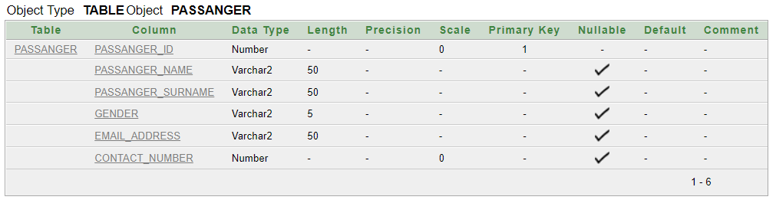

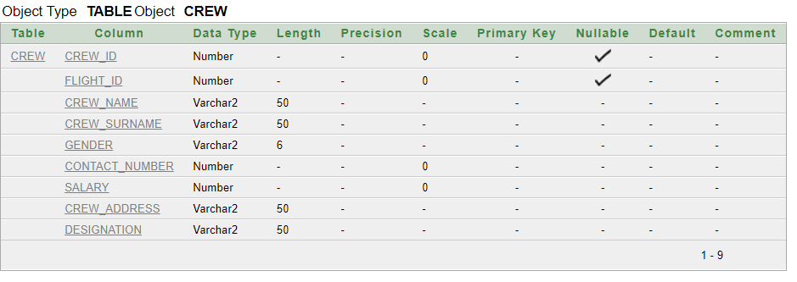

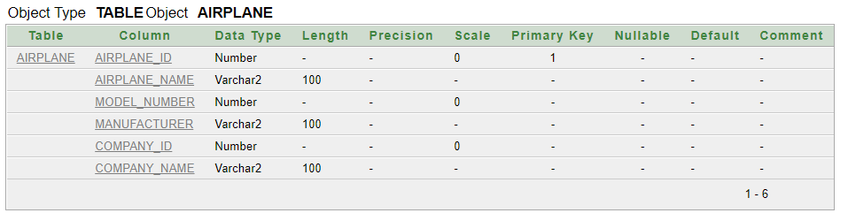

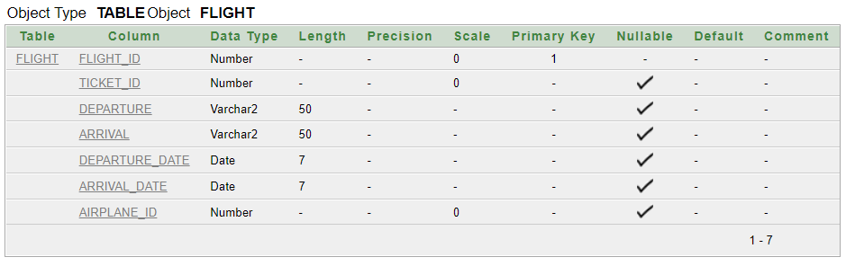

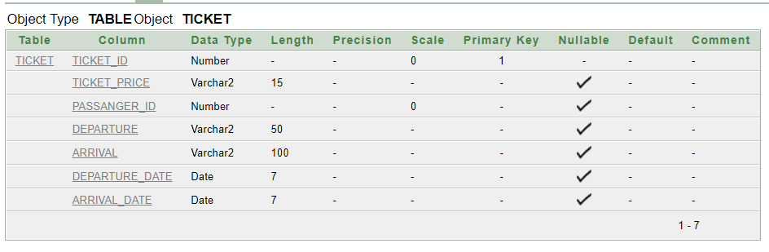

PERFORMING DML

IMPLEMENTATION OF DATA

Insert into Passanger(Passanger_id , Passanger_name, Passanger_surname ,Gender ,Email_address ,Contact_number )
values(79210,'Abdul Rehman','Wachocho','M','Wachocho@gmail.com',0312234212 );
values(79211,'Abdul Sami','Wadho','M','samiwadho@gmail.com',031242412 );
values(79212,'kashif Hussain','Wachocho','M','kashif@gmail.com',0333234212 );
values(79213,'Sabir Ali','Hakro','M','Sabir@gmail.com',0345554323 );
values(77443,'Safder Shah','Shah','M','Shah@gmail.com',0312325777);
values(24444,'Zanib gul','khan','M','Zanib@gmail.com',0317777888 );
values(25333,'Abdulluah','Wadho','M','Abdulluah@gmail.com',0305556696 );
values(33211,'Abdul Ghaffer','kori','M','Ghaffer@gmail.com',0333999944 );
values(42112,'Abdul Ahad','Lashari','M','Ahad@gmail.com',0315665656 );
values(98989,'Nida sami','Rajpot','M','Nida@gmail.com',03166666655 );
values(77666,'Kubra khan','Khan','M','Kubra@gmail.com',0345666664 );
values(66644,'Abdul Samed','Sommro','M','Sommro@gmail.com',036455565 );

Insert into AIRPLANE(Airplane_id ,Airplane_name ,Model_number,Manufacturer ,Company_id )
values(980110,'Iqbal fly',302,'German',33412802);
values(931110,'Big Fly',367,'Englind',5423337);
values(912356,'Round Chick',321,'China',33421223);
values(942154,'Arid Arrow',425,'American',34444402);
values(932221,'Night fly',643,'American',34444402);
values(924492,'Jinnah fly',123,'China',33421223);
values(976544,'Capable Craft',970,'German',33412802);
values(984322,'Red King',234,'China',33421223);
values(943232,'Round Chick',302,'German',33412802);

Insert into Ticket(Ticket_id ,Ticket_price ,Passanger_id , Departure ,Arrival , Departure_date,Arrival_date)
Values(00012,50000,79210,'Karachi','Dubai',to_date('03/01/2020','dd/mm/yyyy'),to_date('03/01/2020','dd/mm/yyyy');
Values(00013,50000,79211,'Karachi','Dubai',to_date('03/01/2020','dd/mm/yyyy'),to_date('03/01/2020','dd/mm/yyyy'));
Values(00321,150000,77443,'Dubai','Qatar',to_date('04/01/2020','dd/mm/yyyy'),to_date('05/01/2020','dd/mm/yyyy'));
Values(01321,200000,24444,'Dubai','Texis',to_date('05/01/2020','dd/mm/yyyy'),to_date('06/01/2020','dd/mm/yyyy'));
Values(00123,100000,25333,'Dubai','France',to_date('05/01/2020','dd/mm/yyyy'),to_date('06/01/2020','dd/mm/yyyy'));
Values(03242,35000,33211,'Lahore','Mumbay',to_date('07/01/2020','dd/mm/yyyy'),to_date('07/01/2020','dd/mm/yyyy'));
Values(04321,30000,42112,'Karachi','Dhaka',to_date('06/01/2020','dd/mm/yyyy'),to_date('06/01/2020','dd/mm/yyyy'));
Values(03421,90000,98989,'Dubai','Moscow',to_date('08/01/2020','dd/mm/yyyy'),to_date('08/01/2020','dd/mm/yyyy'));
Values(03222,30000,77666,'Islambad','Dubai',to_date('09/01/2020','dd/mm/yyyy'),to_date('09/01/2020','dd/mm/yyyy'));
Values(00015,50000,79213,'Karachi','Dubai',to_date('03/01/2020','dd/mm/yyyy'),to_date('03/01/2020','dd/mm/yyyy'));
Values(02323,39000,66644,'Lahore','New Delhi',to_date('06/01/2020','dd/mm/yyyy'),to_date('06/01/2020','dd/mm/yyyy'));
Values(00014,50000,79212,'Karachi','Dubai',to_date('03/01/2020','dd/mm/yyyy'),to_date('03/01/2020','dd/mm/yyyy'));

Insert into FLIGHT(Flight_id , Ticket_id,Departure ,Arrival ,Departure_date ,Arrival_date ,Airplane_id)
Values(570999,00012,'Karachi','Dubai',to_date('03/01/2020','dd/mm/yyyy'),to_date('03/01/2020','dd/mm/yyyy'),924492);
Values(570999,00013,'Karachi','Dubai',to_date('03/01/2020','dd/mm/yyyy'),to_date('03/01/2020','dd/mm/yyyy'),924492);
Values(570323,00321,'Dubai','Qatar',to_date('04/01/2020','dd/mm/yyyy'),to_date('05/01/2020','dd/mm/yyyy'),912356);
Values(570523,01321,'Dubai','Texis',to_date('05/01/2020','dd/mm/yyyy'),to_date('06/01/2020','dd/mm/yyyy'),931110);
Values(542339,00123,'Dubai','France',to_date('05/01/2020','dd/mm/yyyy'),to_date('06/01/2020','dd/mm/yyyy'),980110);
Values(570999,03242,'Lahore','Mumbay',to_date('07/01/2020','dd/mm/yyyy'),to_date('07/01/2020','dd/mm/yyyy'),943232);
Values(574233,04321,'Karachi','Dhaka',to_date('06/01/2020','dd/mm/yyyy'),to_date('06/01/2020','dd/mm/yyyy'),932221);
Values(574329,03421,'Dubai','Moscow',to_date('08/01/2020','dd/mm/yyyy'),to_date('08/01/2020','dd/mm/yyyy'),980110);
Values(572323,03222,'Islambad','Dubai',to_date('09/01/2020','dd/mm/yyyy'),to_date('09/01/2020','dd/mm/yyyy'),943232);
Values(570999,00015,'Karachi','Dubai',to_date('03/01/2020','dd/mm/yyyy'),to_date('03/01/2020','dd/mm/yyyy'),924492);
Values(53229,02323,'Lahore','New Delhi',to_date('06/01/2020','dd/mm/yyyy'),to_date('06/01/2020','dd/mm/yyyy'),932221);
Values(570999,00014,'Karachi','Dubai',to_date('03/01/2020','dd/mm/yyyy'),to_date('03/01/2020','dd/mm/yyyy'),924492);

Insert into Crew(Crew_id ,Flight_id , Crew_name ,Crew_surname ,Gender ,Contact_number , Salary, Crew_address, Desegination)
values(900290,570999,'Abdul Ahad','Gujjar','M',923433543341,150000,'Old power house north karachi','Pilot');
values(900291,570999,'Abdul Sami','Mughal','M',923123453312,88000,'Gulshan-e-Johar block 7','Crew_staff');
values(900292,570999,'Anna Mustafa','Rajpoot','F',923433003323,95000,'Gulshan-e-Iqbal block 2','Crew_staff');
values(988777,542339,'Zesshan Hussain','Jutt ','M',923433543341,125000,'Gulshan-e-Johar block 9','Pilot');
values(988778,542339,'Sameera Ayan','Lashari','F',923143344444,90000,'Gulshan-e- Iqbal block 6','Crew_staff');
values(988779,542339,'Fatima','Butt','F',923466633777,80000,'Gulshan-e-Johar block 5','Crew_staff');
values(866662,574233,'Sabir Ali','Wadho','M',923334555566,150000,'Gulshan-e- Iqbal block 18','Pilot');
values(866663,574233,'Ali Raza','Sheikh','M',923312424323,99000,'Gulshan-e-Johar block 8','Crew_staff');
values(866664,574233,'Alina Sami','Butt','F',923499966667,80000,'Gulshan-e- Iqbal block 18','Crew_staff');
values(477885,570999,'Ahmed hussain','Arain','M',923434332335,60000,'Shah Faisal block 15','Pilot');
values(477886,570999,'Baber Ali','Jogi','M',923056455555,60000,'Gulshan-e- Iqbal block 18','Crew_staff');
values(477887,570999,'Daniyal Ahmed','Khan','M',923434332335,67000,'Gulshan-e- Iqbal block 18','Crew_staff');
values(677738,574233,'Faisal Ali','Shah','M',923433003323,95000,'Shah Faisal block 1','Pilot');
values(677739,574233,'Ibrahim Shah','Wani','M',923022224412,50000,'Kachi colany block 14','Crew_staff');
values(677740,574233,'Imran Ali','Talpur','M',923333900011,80000,'Gulshan-e-Johar block 13','Crew_staff');
values(239995,574329,'Umar Taj','Zardari','M',923433003323,95000,'Shah Faisal block 3','Pilot');
values(239996,574329,'Tanveer Ali','Hakro','M',92319233422,89000,'Gulshan-e-Iqbal block 2','Crew_staff');
values(239997,574329,'Ibrahim Shah','Wani','M',923022224412,50000,'Kachi colany block 14','Crew_staff');
values(899772,572323,'Fayaz Ahmed','Qureshi','M',923023244455,150000,'Gulshan-e-Johar block 6','Pilot');
values(899773,572323,'Sadique Ali','Lakho','M',923645555444,90000,'Gulshan-e-Johar block 4','Crew_staff');
values(899774,572323,'Usama Mustafa','Wadho','M',92319433335,96000,'Gulshan-e-Iqbal block 9','Crew_staff');

DISPLAY OF IMPLEMENTATION

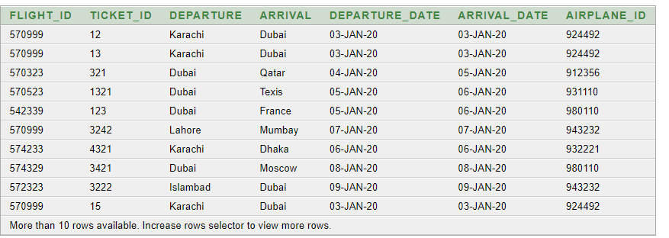

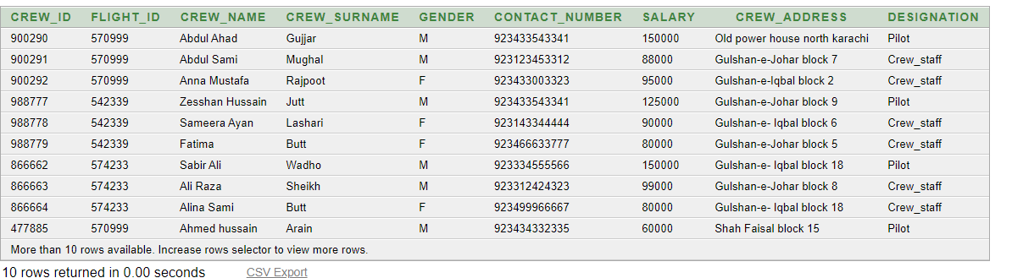

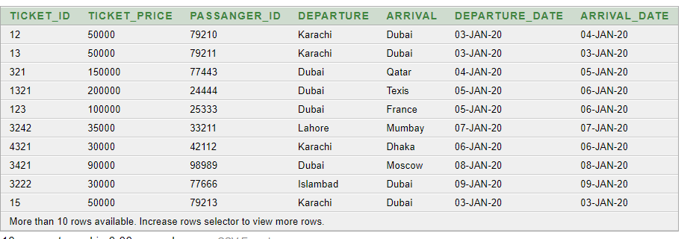

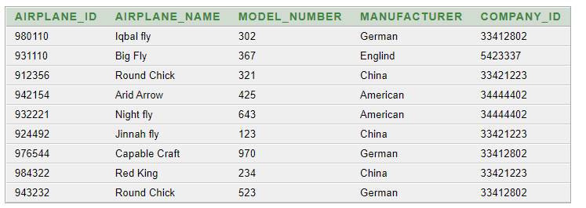

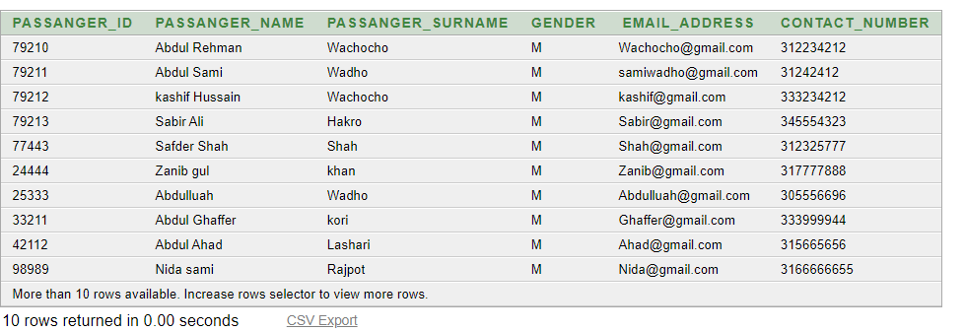

QUERIES FOR RETRIEVING DATA

